Project Report

ParkinSon: A Machine Learning Approach for Early Detection of Parkinson’s Disease Through Motion Sensing

TEAM MEMBERS:

Shrinikhaythan

Aakash Jude Anthony

Aditri S. Madhavan

ParkinSon: A Machine Learning Approach for Early Detection of Parkinson’s Disease Through Motion Sensing

1. Problem Statement:

Parkinson’s Disease (PD) is a progressive neurodegenerative disorder that affects movement control, often characterized by tremors, stiffness, and slowness of motion. Early detection of Parkinson’s can significantly improve patient quality of life through timely medical intervention and lifestyle management. However, current diagnostic methods are primarily clinical and subjective, relying on neurological examinations that may overlook subtle early-stage symptoms. There is a growing need for a low-cost, portable, and objective system capable of continuously monitoring motor activity and identifying abnormal tremor patterns indicative of Parkinson’s Disease. ParkinSense aims to address this gap by integrating a Raspberry Pi Zero 2 with an MPU-6050 motion sensor to collect real-time motion data. Using an unsupervised machine learning approach—specifically an autoencoder for anomaly detection—the system identifies deviations from normal motion patterns, providing a scalable and affordable solution for early Parkinson’s screening and remote health monitoring.

2. Literature Review

Reference paper | Paper Description | Limitation
Detecting Parkinsonian Tremor from IMU Data Collected In-The-Wild using Deep Multiple-Instance Learning (Papadopoulos et al., 2020) | This paper presents a method using IMU (accelerometer) data collected “in the wild” (smartphones) to detect tremorous episodes associated with Parkinson’s Disease. They use a multiple-instance learning (MIL) approach: each subject is represented as a bag of accelerometer segments and a single tremor-annotation. The algorithm learns deep features and a pooling stage to identify key tremor-instances. | Because the data was collected in uncontrolled “wild” environments, label quality and noise are high; also the approach assumes wrist/phone IMU only, not a dedicated sensor board as our hardware.
Unsupervised Pre-trained Models from Healthy ADLs Improve Parkinson’s Disease Classification of Gait Patterns (Som et al., 2020) | Here the authors use a convolutional autoencoder (unsupervised) trained on data from healthy subjects performing ADLs (Activities of Daily Living) using accelerometer sensors. Then they adapt that model (feature extractor) for Parkinson’s disease gait-classification. This is very relevant to our unsupervised autoencoder approach. | The focus is on gait patterns rather than small-motion tremors of hands, and the sensor setup differs (gait vs hand/limb IMU). So direct adaptation to our hand sensor/MPU context might require adjustments.
Parkinson’s disease detection from EEG signal employing autoencoder and RBFNN-based hybrid deep learning framework utilising power spectral density (Jibon et al., 2024) | This recent study uses an autoencoder + RBF Neural Network on EEG data (power spectral density of multiple channels) to classify Parkinson’s vs healthy. They claim high accuracy (~99%) and show how autoencoder can extract features from physiological signals. | Although they use autoencoder (good match), their modality is EEG (brain waves) rather than IMU motion sensing. So hardware, sensor-type and signal dynamics differ from our tremor/IMU setup.

3.Proposed Work

To develop an intelligent and portable system for early detection of Parkinson’s Disease through tremor analysis. The system employs a Raspberry Pi Zero 2 as the central processing unit, integrated with an MPU-1615 motion sensor to record real-time hand movement data, including accelerometer and gyroscope readings. The collected data is preprocessed and fed into an unsupervised machine learning model—specifically, an autoencoder—to identify abnormal tremor patterns indicative of Parkinson’s symptoms. The model is trained using normal motion data to establish a baseline, enabling it to detect deviations as potential anomalies. The entire system is coded in Python, optimized for Raspberry Pi operation, and tested for accuracy, sensitivity, and response time. This compact setup provides a low-cost, efficient, and continuous monitoring solution, aimed at supporting early screening and remote health assessment for individuals at risk of Parkinson’s Disease.

4. Block Diagram

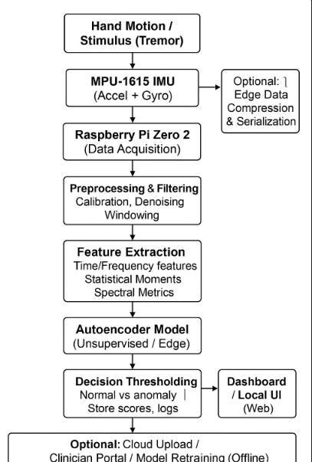

5. Block Diagram Explanation:
The block diagram illustrates the functional flow of the proposed ParkinSense system, which detects Parkinson’s-like tremors using sensor data and machine learning.
- Hand Motion / Stimulus (Tremor):
The system begins with hand movement or tremor generated by the user. This motion serves as the physical input stimulus that needs to be analyzed.
- MPU-1615 IMU (Accelerometer + Gyroscope):
The MPU-6050 sensor captures real-time acceleration and angular velocity values corresponding to the hand’s movement in three axes (X, Y, and Z). These raw signals represent the dynamic behavior of the hand.
- Raspberry Pi Zero 2 (Data Acquisition):
The Raspberry Pi Zero 2 collects data transmitted from the IMU through an I²C or SPI interface. It timestamps and stores this sensor data for further processing.
- Preprocessing and Filtering:
The raw motion data often contains noise and bias. This stage performs calibration, filtering (using techniques like low-pass or moving average), and segmentation of data into fixed time windows to make it suitable for feature extraction.
- Feature Extraction:
Relevant features are computed from each window of data, such as statistical metrics (mean, variance, RMS), frequency-domain features(using Fast Fourier Transform), and signal entropy. These features summarize the motion behavior efficiently.
- Autoencoder Model (Unsupervised Learning):
The extracted features are fed into an autoencoder model trained on normal motion data. During operation, the model reconstructs the input; any significant reconstruction error indicates an abnormal tremor pattern, possibly linked to Parkinson’s symptoms.
- Decision Thresholding:
The system compares the reconstruction error with a preset threshold based on the testing of the autoencoder model. If the error exceeds the threshold, it flags the motion as anomalous (potential tremor); otherwise, it is considered normal.

6. List of Components and Cost Analysis:

S.No | Components name | Quantity Required | Cost
1 | Raspberry Pi Zero 2 | 1 | Rs. 2050
2 | MPU 6050 | 1 | Rs. 200
3 | Jumper wires | A few | Rs. 60
4 | Connecting Cable | 1 | Rs.150
Total Product Cost |  |  | Rs.2460

7. Output -Photo Snapshot

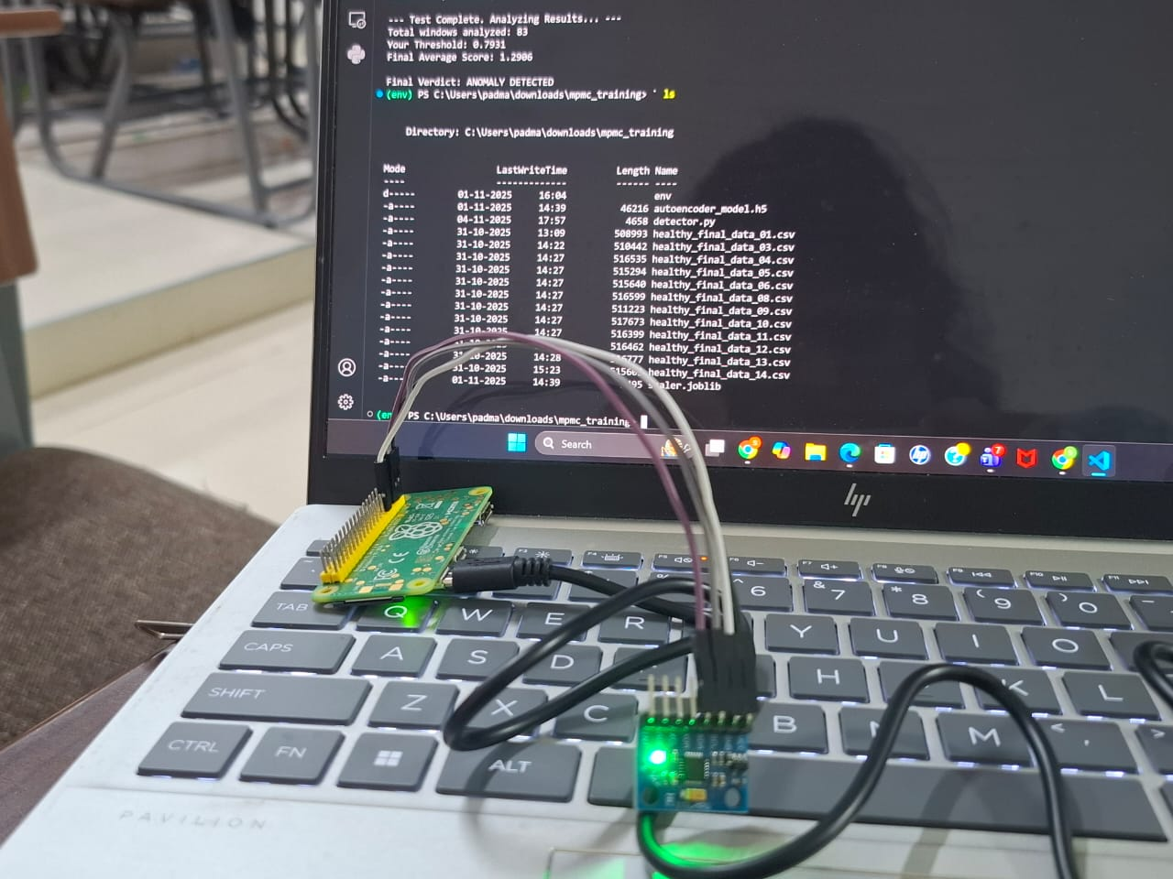

8.References:
1. Detecting Parkinsonian Tremor from IMU Data Collected In-The-Wild using Deep Multiple-Instance Learning (Papadopoulos et al., 2020)
2. Unsupervised Pre-trained Models from Healthy ADLs Improve Parkinson’s Disease Classification of Gait Patterns (Som et al., 2020)
3. Parkinson’s disease detection from EEG signal employing autoencoder and RBFNN-based hybrid deep learning framework utilising power spectral density (Jibon et al., 2024)

